Computers as Objects to Think With

Overview
In this session we will consider the idea of computers as objects to think with. This relates to how computers and possibly the system you are developing could be used to help learners appreciate quite difficult concepts in an accessible manner.
One practical implementation of this is the ‘microworld’ concept. A microworld may be seen as a constrained version of reality where an idea may be modelled or simulated without the distraction of having to consider all of the details and implications.

Computers as Objects to Think with
When I was at school computers weren’t really a thing. A friend of mine announced he had built his on computer using a kit, a Sinclair ZX80.
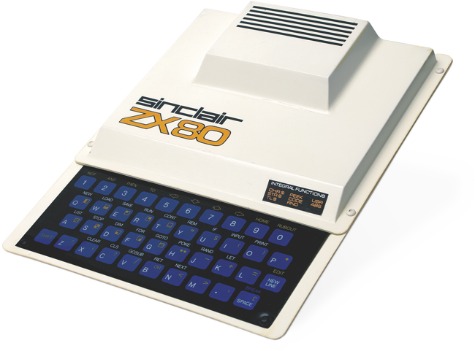
The ZX80 had 1K of memory, no hard disk drive and no mouse. When you ran a program, the screen would go black because it didn’t have enough processing power to run program and display an image at the same time.
Given that there was no long terms storage, if you wanted it to do anything you had to type the program in yourself using the rather awkward keyboard. There was an option to attach a tape recorder to the computer and save your programs on tape, but in all the time I owned one I never got it to work. It also had a habit of re-booting itself whenever my mum used the vacuum cleaner.
When I saw my friend’s computer that he had built himself I knew I had to have one. In part this was from watching too much Star Trek, but I also knew instinctively that this was the future. He and his family had to move to Canada so he sold me the computer for £35 and I was now the only person at school with a computer.
Eventually computers did appear at schools. My physics teacher had a BBC micro and I would sometimes spend my lunch hour messing with it and writing code. The A level business course had some PET computers which I wasn’t allowed near. One day my maths teacher set up a lunch time computer club. He brought in his rather expensive Apple IIe, it was this moment that I discovered that I knew far more about computers then most of my teachers.
The thing is in physics I had realised a formula could be entered into a computer and it could be made to calculate the answer for me. This meant I was now doing my physics homework using my computer. There was a slight problem though, my humble ZX80 couldn’t count in decimal numbers, so I got marked down as all of my answers had been rounded off to the nearest integer.
It did make me realise though that it was possible to model physical concepts in a computer. The graphics at the time weren’t up to much but you could create a numerical output to get a sense of what was going on.
I decided therefore to model the rotation of the plants around the sun to get a sense of the size of the solar system. I think I got to the orbit of Jupiter and then found the computer crashed as the largest integer number was 65535.
What I am driving at with this story is how the computer became an exciting playground where I could model physical properties of the world around me and also learn the limitations of the computer technology to hand. I came away from that last experiment, modelling the solar system, with a deep appreciation that the distance to the outer planets was in fact huge.
In these examples the computer had become “an object to think with”.
The idea of computers as objects to think with is discussed by Semour Papert in his book Mindstorms and in so doing introduces the idea of a microworld.

What is a microworld?
“a “place”, a “province of Mathland”, where certain kinds of mathematical thinking could hatch and grow with particular ease. The microworld was an incubator... The design of the microworld makes it a “growing place” for a specific species of powerful ideas or intellectual structures.”
(Papert, 1980, p. 125)
“environments where people can explore and learn from what they receive back from the computer in return for their exploration. It follows, therefore, that a microworld has its own set of tools and operations that are open for inspection and change. In this sense, learners themselves are in the position simultaneously of user and designer.”
(Hoyles et al, 2002: 30)

Take a Break
3x handouts
- Each is summary of microworld-based research case study
- Highlight benefits for learners from engaging with microworld environments
- Highlight challenges, cautions or limitations identified by researchers

Key Features of Microworlds
- Models mathematical or physical properties of a particular ‘domain’
- But ‘micro’ because some more complex aspects of the ‘real’ domain have been left out – i.e. simplified reality
- So makes abstract ideas ‘concrete’ but in a controlled, scaffolded way
- Enables multiple representations of these underlying properties
- Users can interact with microworld to change these properties and receive feedback on the results – i.e. they naturally promote exploratory/discovery learning
- BUT the process is managed/scaffolded by the teacher – this is not free play, but a semi-guided process because the ‘world’ has been set up
- Learners challenged to solve problems or reach goal using microworld
- ‘Debugging’ of faulty assumptions and wrong understandings is natural part of process – they can be tested and checked as users interact

